Amarjeet kaur jc326638

**Project Plan:**

**Goals :-**  Today, Many people prefer to buy the things via internet instead of walk to local department store or retail shop. Due to growing industry of fashion, women want everything perfect in their life. The internet is very big marketplace and customer/clients can buy and sell anything or everything via internet. Handbag is the one of the fashion accessory in the world. Women can select the handbag via internet handbag website which one they prefer according to their choices and budget. We provide every types of handbags. Such as Handbags, luggage, wallets and backpacks along with price and image of that bag. Women can click on website link and choose that bag which one they want. Our website accessible is very easily. Anyone can access easily. It will also save the time of customers.

**Success Evaluation:-**

* **Technology (Browser & OS):**Comparing metrics across browsers and operating systems informs whether the website is properly optimized on all platforms. If page visits, site visit duration, or bounce rates for one platform are lagging noticeably behind the others, there is likely an issue that needs to be addressed.
* **Demographics**: Are most visitors from the local area — meaning they are potential customers — or are they individuals in far-off places who stumbled upon the site but likely won’t ever engage the business? It’s key to understand whether the right consumers are making it to the site. If only a handful of total website visits come from local consumers, the business needs to evaluate its SEO/SEM approach.
* **Bounce Rate:** Similar to engagement, this indicates the percentage of visitors who left the site without moving on to another page from the one they landed on. A high bounce rate means the site is failing to entice visitors to stay and learn more about the business.
* **Mobile:** Evaluating performance indicators for those accessing the site through desktop, mobile or tablet is valuable in determining whether the site is properly optimized for each platform. But it isn’t just about taking desktop website content and reformatting it in a mobile-friendly way. Local businesses need to think through their mobile and tablet experiences to determine what website information and flow is best in each of these settings.
* **Visitors Flow:**This flow map indicates how visitors are engaging with the site throughout their visit. The interface can be customized to show how specific types of users travel through the site.
* **Feedback:** User can fill the feedback form. How much they like ouyr website. And they can also give the suggestion to improve the website accessible.

**Target Audience:-**

Collage/university girls, Business women, housewives, for travel.

**Screen Shot**

1.Home page

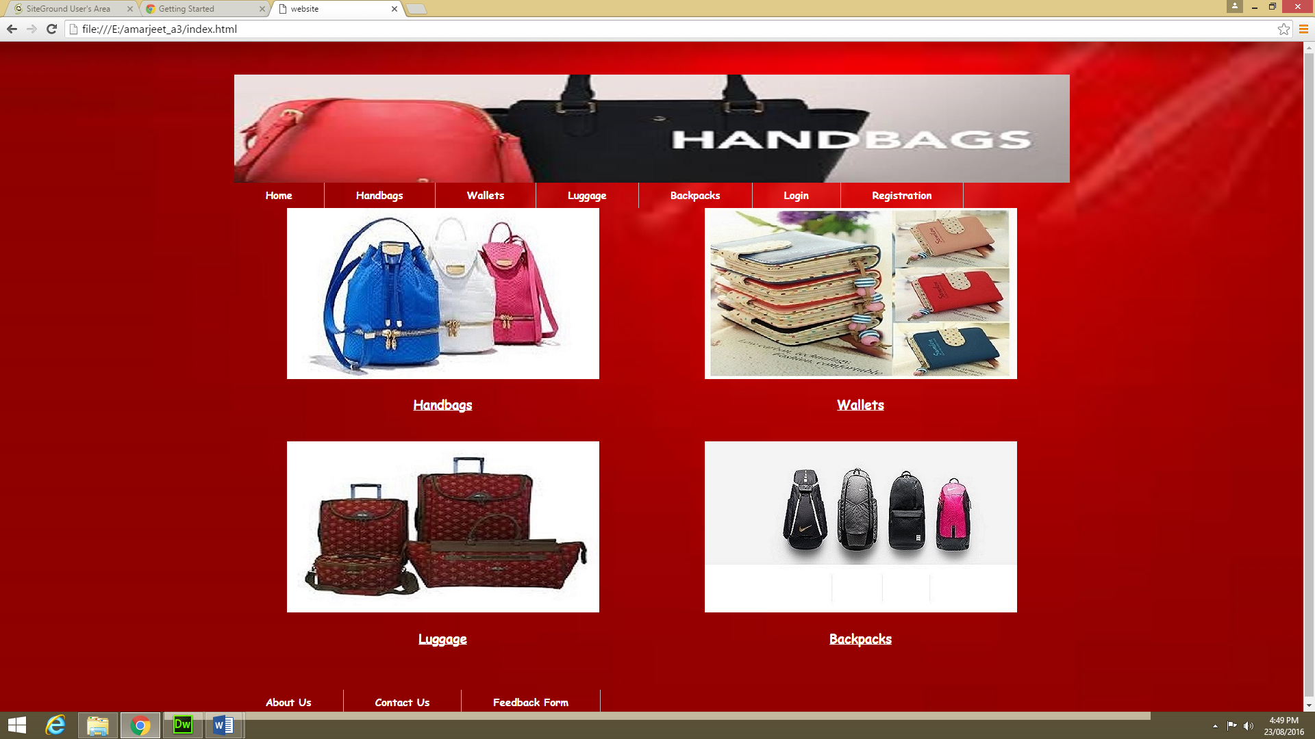

2. backpacks

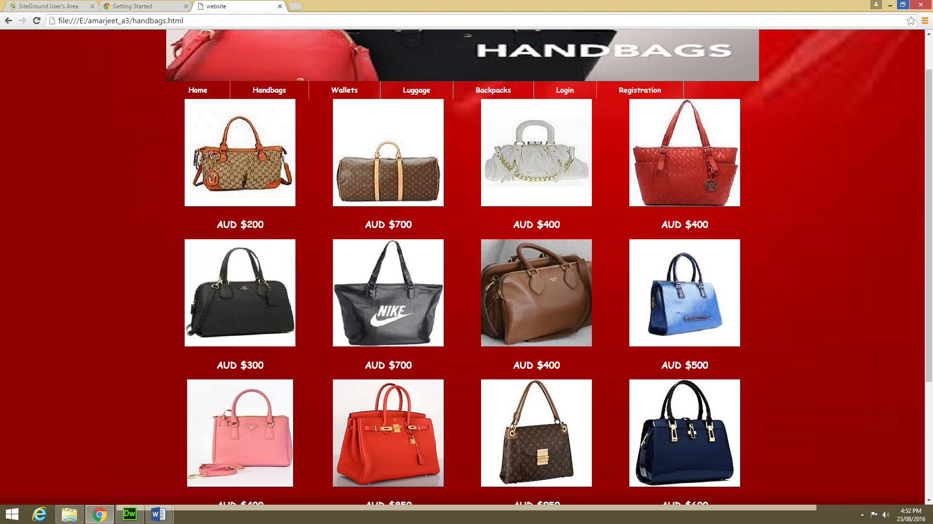

3.luggage

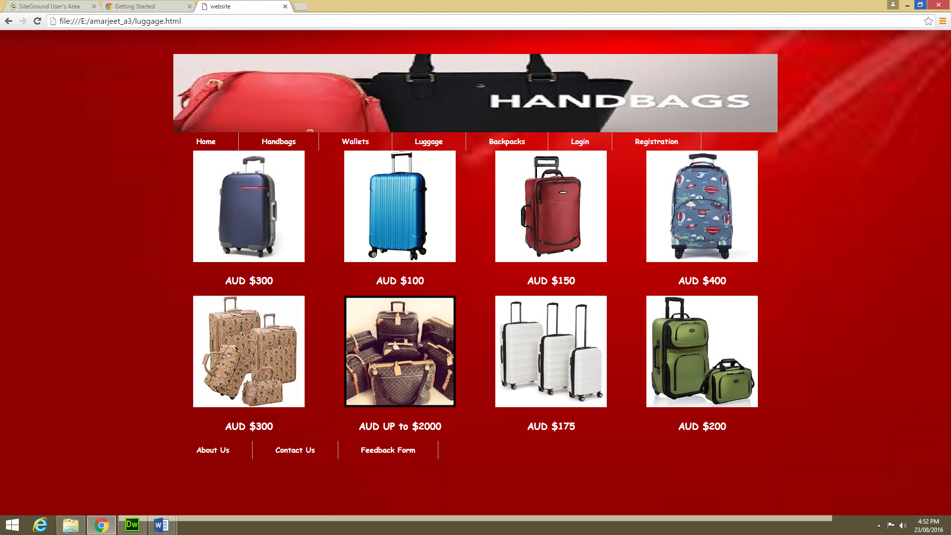

4.backpacks

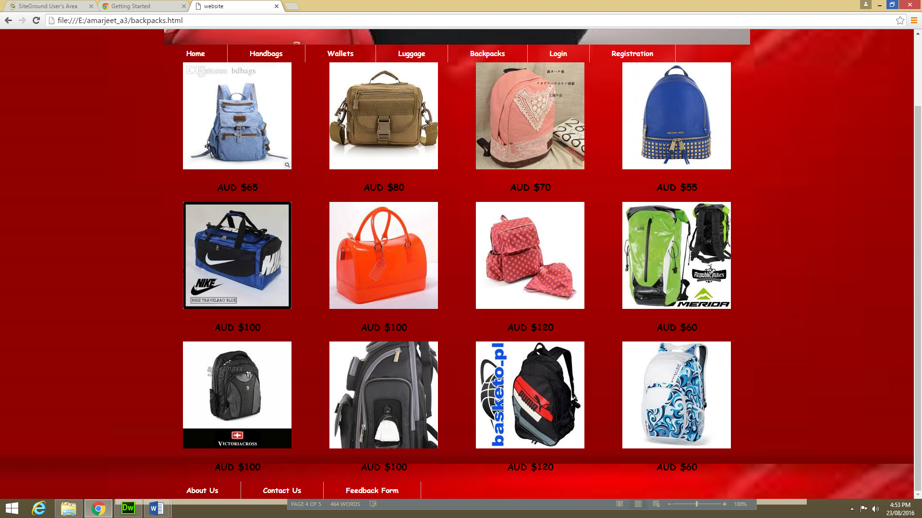

5.login

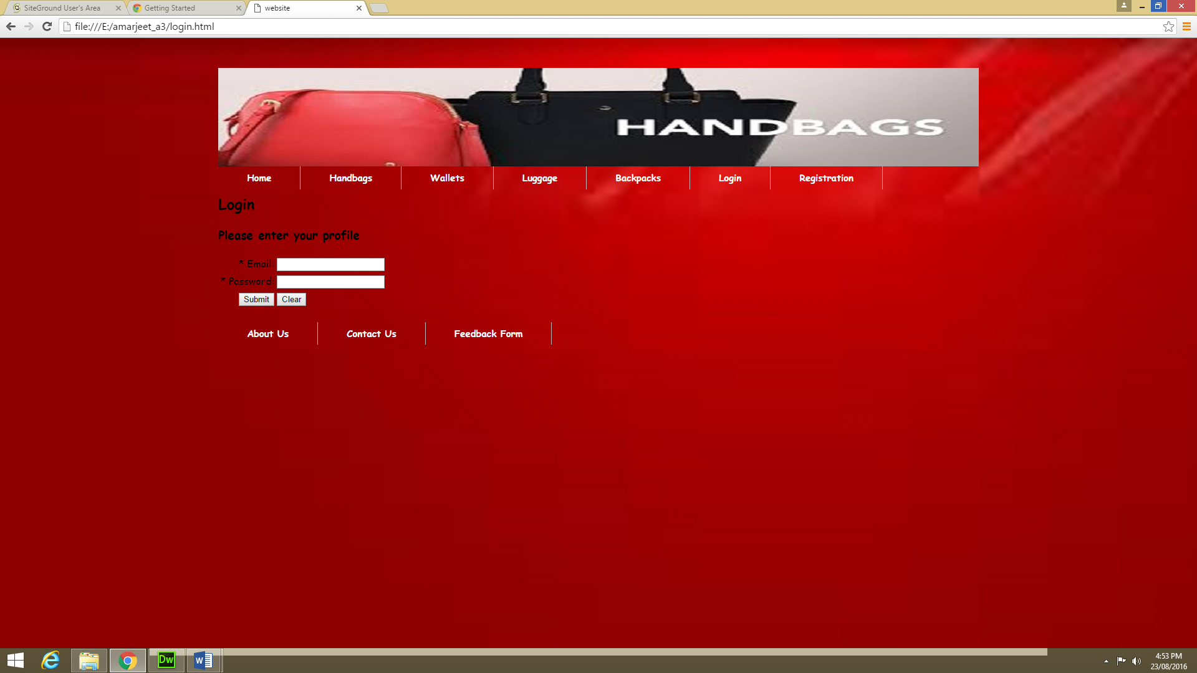

6.registration

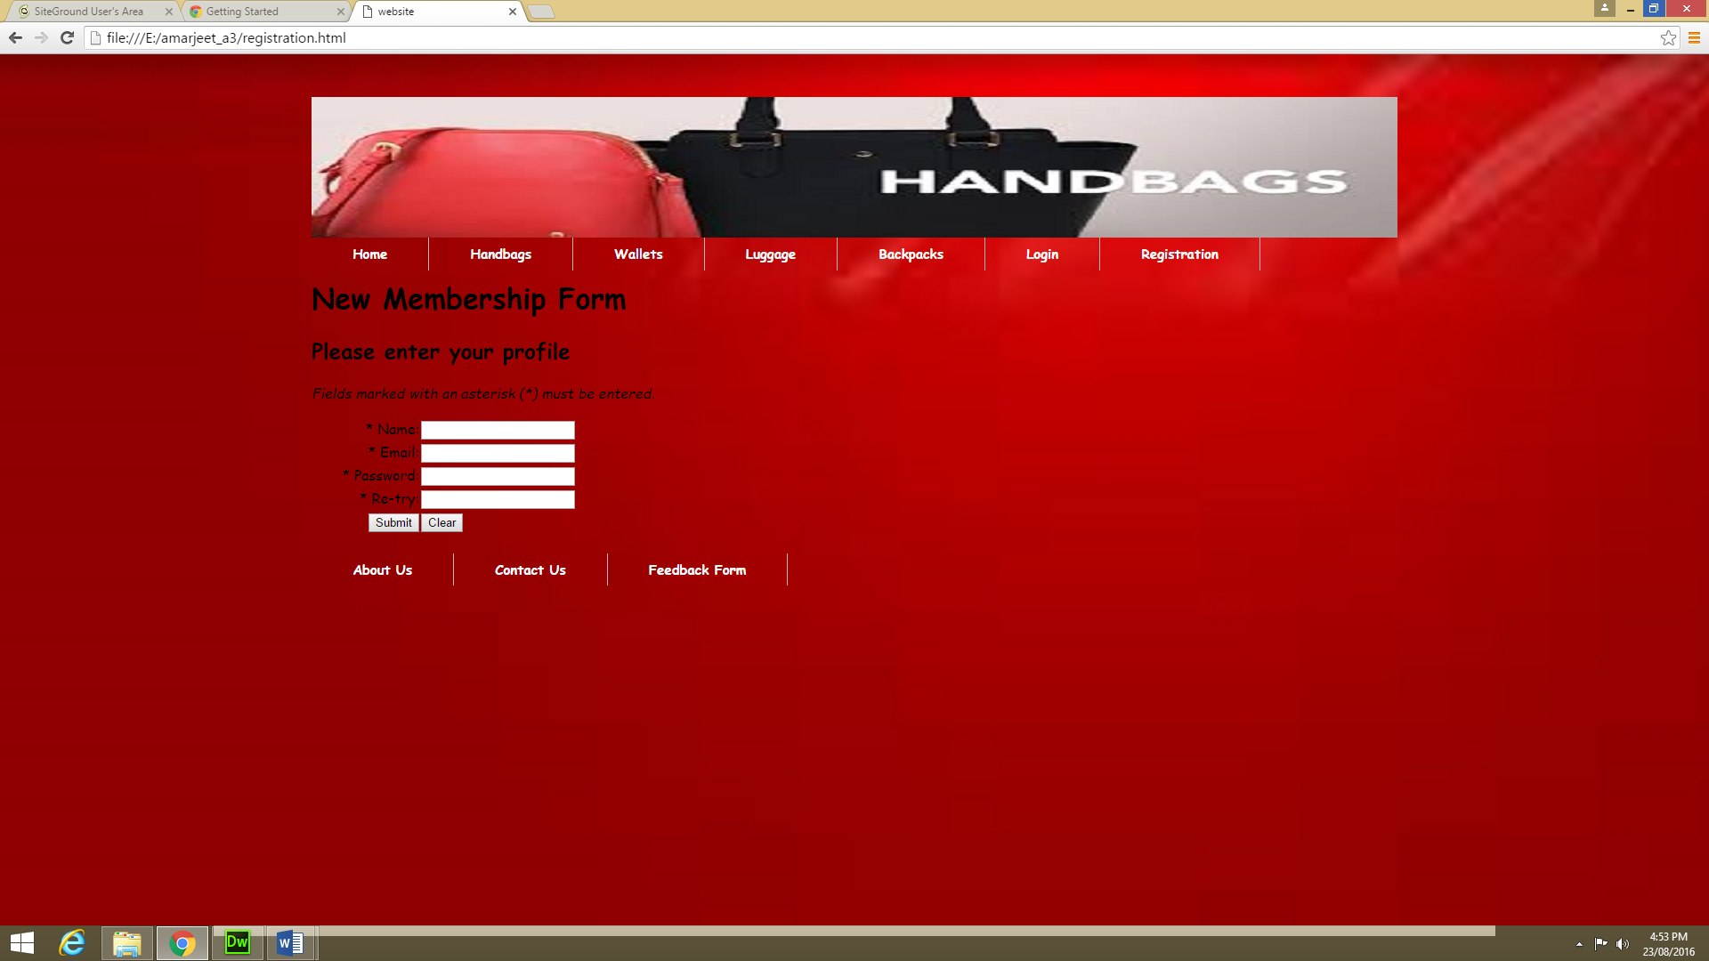

7.Wallets

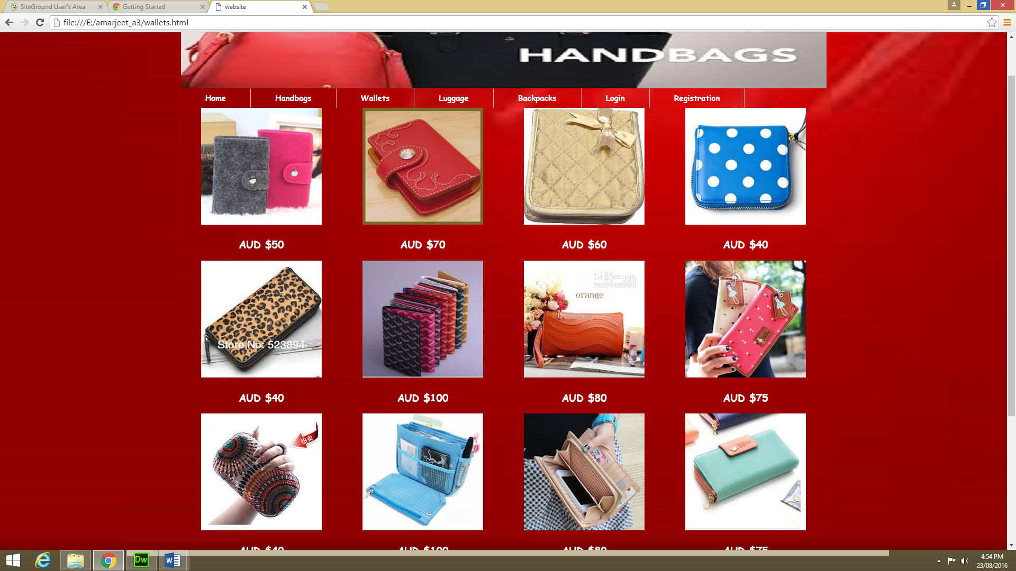

8.about us

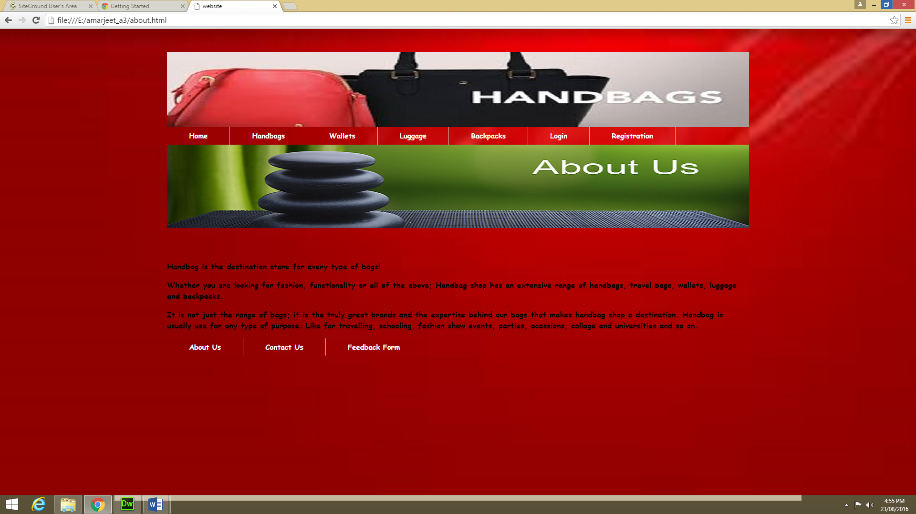

9.Contac us

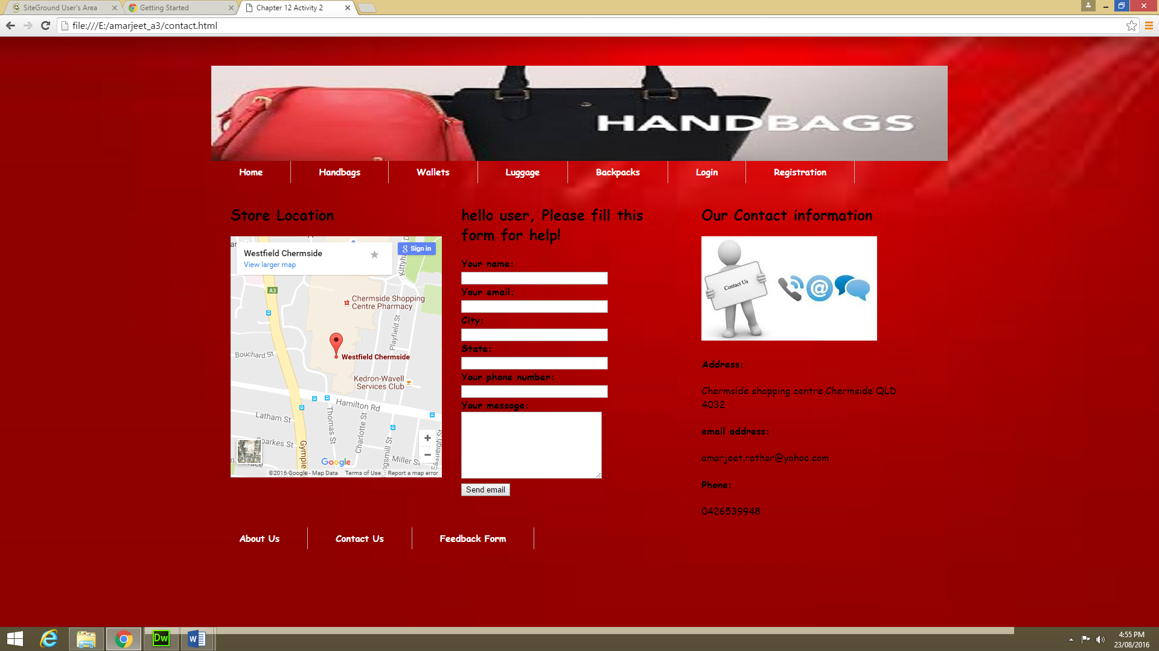

10.Feedback form

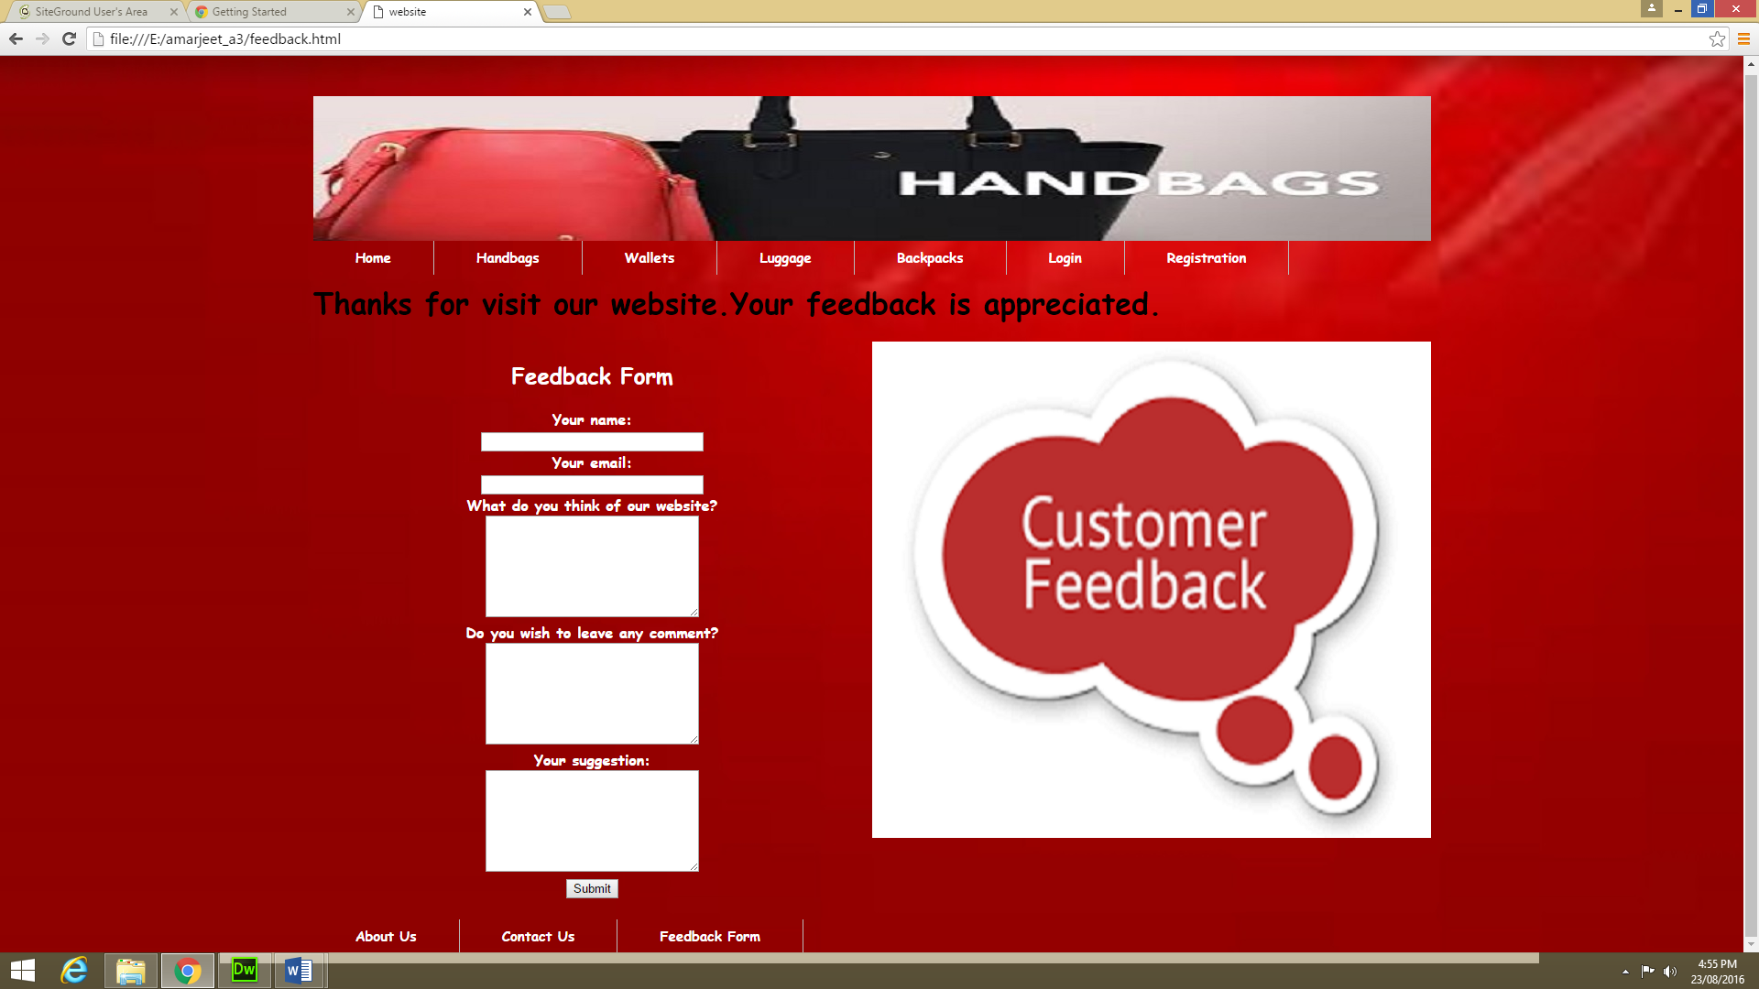

**Flow chart of handbag website:**

It is below.

registration

login

About us

Feedback

Contact us

backpacks

luggage

wallets

handbags

home

User can see the products along with price

User can contact via address and location

Feedback about website and can give suggestion

For already registered user

For New user

Feedback

Registration

Login

Contact us

About us

backpacks

Luggage

wallets

Handbags

Home